12.78: a) The semimajor axis is 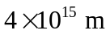and so the period is

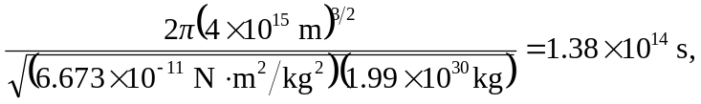

which is about 4 million years. b) Using the earth-sun distance as an estimate for the distance of closest approach, 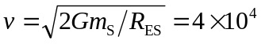
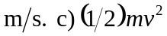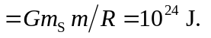 This is far larger than the energy of a volcanic eruption and is comparable to the energy of burning the fossil fuel.

